ANIMATRONICS FACE: Dr. Zhigang Feng

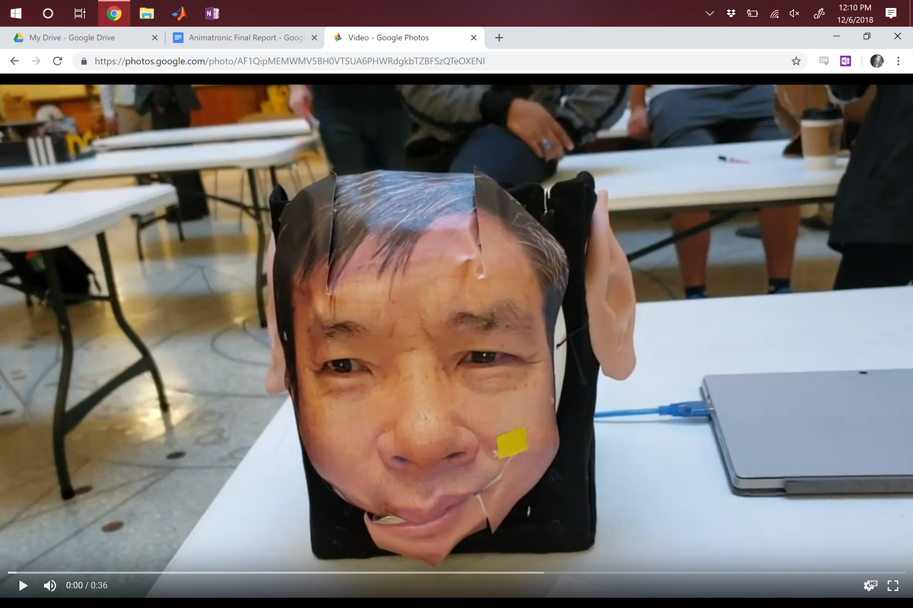

Gerson Velasquez

Dept. of Mechanical Engineering

San Antonio, TX, USA 78249

[gers1015@gmail.com](mailto:gers1015@gmail.com)

Zom983

Eduardo Garcia

Dept. of Mechanical Engineering

San Antonio, TX, USA 78249

yow973@my.utsa.edu

Alison Toms

Dept. of Mechanical Engineering

San Antonio, TX, USA 78249

cbd338@my.utsa.edu

Submitted as part of project for ME4543 Mechatronics, Fall 2018

Link to Video: <https://youtu.be/DpBf18SqIkg>

TABLE OF CONTENTS

|  |  |
| --- | --- |
| Abstract | 3 |
| Literature Review | 4 |
| Brainstorming | 5 |
| Supporting Structure | 5 |
| Joints and Motors | 6 |
| Sensors | 6 |
| Programming | 7 |
| Lesson learnt and suggestions | 8 |
| Personnel and Bill of Materials | 9 |
| Appendix A: Code | 12 |
| Appendix B: Arduino Wiring | 15 |
| Appendix B: Figures | 16 |

ABSTRACT

The Mechatronics class was tasked with creating an animatronic face of a UTSA Mechanical Engineering professor. Two sensors were required to produce two separate outputs on different parts of the face, one of which was to be a moving mouth. An Arduino was provided, which was to be the brain of the face. A cubic frame was created out of steel bar and covered in black cloth. A Halloween mask was added to the front of the frame, with the chin cut from the rest of the mask in order to allow movement. A wire was attached from the chin to a servo motor. Two ears were glued to the side of the frame, again with each attached to its own servo motor. In this project, a capacitive touch sensor was used to initiate mouth movement, and a magnetic reed switch was used to initiate wiggling ears. Dr. Zhigang Feng’s face was printed out and glued to the mask. The touch sensor was mounted behind the cheek, so pressing on the cheek would cause the ears to wiggle back and forth. The reed switch was mounted behind the forehead, so a magnet on the face caused the mouth to move up and down. The initial goal was to sync the mouth movement with an MP3 file of Dr. Feng’s voice, but the coding was too difficult for our mechanical team to complete.

Section 1: Literature review

The first project researched is a homemade Halloween decoration: a skull that turns to look and follow a person as they walk by, as seen in Figure 1 and referenced in Smith [3]. In this example, the actual hardware of the face was not important, so a store-bought skull was used. The concept studied here was the wiring and programming to allow the skull to detect the location of a person and track them as they move. It uses an array of photoresistors, an Arduino Uno, and a small Servo motor attached at the base of the skull. The photoresistors are wired in series with a DC power supply. The Arduino code detects light input into each photoresistor mounted on a shelf to detect a person’s shadow and turns the head accordingly. This project was posted to help DIY-ers create their own Halloween decoration with simple items rather than spending a lot of money on something from the store.

Maxwell is a robotic face built by Mark Medonis, seen in Figure 2. This animatronic face has the basic shape of a human head along with eyes and a mouth that opens and closes. The face is healed in place with a wooden chassis. The face is made out of plastic. The robot also has a camera on its forehead to that it uses to track human faces so that it can maintain eye contact. It is not stated what was used to control the face but from the pictures it looks like they are using an Arduino Nano. The animatronic has a total of 4 servo motors. Two of the servos are used to move the head up and down, left to right. Another two of the servos are used to move the eyes up and down, left and right. The last servo motor is used to move the jaw.

The third project researched is an animatronic gorilla head created by Marshall Tearle, seen in Figure 3. The gorilla face has many moving parts such as the eyes, eyelids, lips, mouth and jaw; all to portray the natural actions of a gorilla. The skull was created through molding and casting. The rest of the parts such as the teeth and eyes are purchased. The head of the gorilla has two live operating puppeteers through radio controls along with a coded programed sequence of movement. The head uses a servo recorder, a signal reverser and 11 independently controlled servos. The 11 independent servos are needed due to the head having 11 degrees of freedom from areas such as the eyes to help move or “look” around, the eyelids to close, open and squint, jaw the opening and closing the mouth and the lips for movement.

Section 2: Brainstorming (initial planning)

The animatronic face will be based on UTSA Mechanical Engineering professor, Dr. Zhigang Feng. The figure will need a minimum of 2 moving parts with motors and at least two sensors. As a group, it was discussed what would be the best, yet simplest ways to achieve the objectives. To satisfy one of the major requirements of the project, the animatronic face will have a moving mouth, which will open outward and close inward. Using a hard structured mask can provide support for the joints as aluminum wire can be attached to the mask and the motors. The face will also have 2 moving ears which will be one placed on the left and right side of the face. Movements will each be controlled with a single J-deal SG-90 Micro Servo motor. Joints will be supported with aluminum wire which will also help join together the joints and motors. A touch sensor is planned to be used and synced with the mouth. When you touch the sensor the mouth will begin opening and closing as the robot will potentially speak “Hello, I am Dr. Feng and i believe UTSA engineering students are the future.” Another sensor that will be used is a reed switch. When a magnet is brought close, it will make both ears move simultaneously. The system will be powered with either a 9 volt battery/ies or a set of AA batteries, depending on which can be provide the best support.

Section 3: Supporting structure

An important component to developing any robot is the supporting structure. The structure is what shapes the robot to look like whatever the brainstormed outcome is supposed to look like. the structure is what holds the robot together and makes it durable yet fully functional to perform whatever tasks it may need. With this in mind, the idea for the supporting structure was developed using a steel bar with aluminum wires. The steel bar will be cut into about 8 pieces of 6 inches and 2 pieces of 8 inches and using bolts and nuts it will create a rectangle prism like platform. Using the aluminum wire, that will help create any flexible attachments needed along with providing support for the bread board, wires, power source and the joints and motors.

Section 4: Joints and motors

After developing the structure, now came the the joints and motors. There are many possibilities for joints, some could be eyes, eyelids, forehead, jaw and many more. However, for this project the group decided a simpler route and chose to have 3 joints. The Dr. Feng animatronic face will have a moving mouth and chin and it will have 2 moving ears which will be synced together. The mouth will have a fixed axis on the bottom using aluminum wire while on the top will be attached to a servo motor controlled and activated by a touch sensor which will be on the cheek. The goal is for when the mouth achieves to move the robot will also speak in the recording of Dr. Feng saying “Hi, I am Dr. Feng, and i believe UTSA engineering students are the future.”For the ears, each one will be attached to a servo motor and it will be controlled and activated by a magnetic sensor when a magnet is placed on its forehead. By having all the joints supports and the motors appropriately coded and placed, the bot should be able to respond accordingly to all inputs and outputs.

Section 5: Sensors

The sensors used in this project included a touch sensor and a mini magnetic detection sensor. These sensors were used because they are relatively simple to use and troubleshoot. The touch sensor works off of capacitance. Capacitive sensors can detect anything that is conductive or that has a significantly different permittivity than air, like a human body or hand. In other words the sensor is able to sense the electrical capacitance of your finger. The reed switch, a mini magnetic detection sensor, works the principle of the Hall effect, which states that whenever a magnetic field is applied in a direction perpendicular to the flow of electric current in a conductor, a potential difference is induced. This potential difference can be used to detect whether the sensor is in the proximity of a magnet or not.

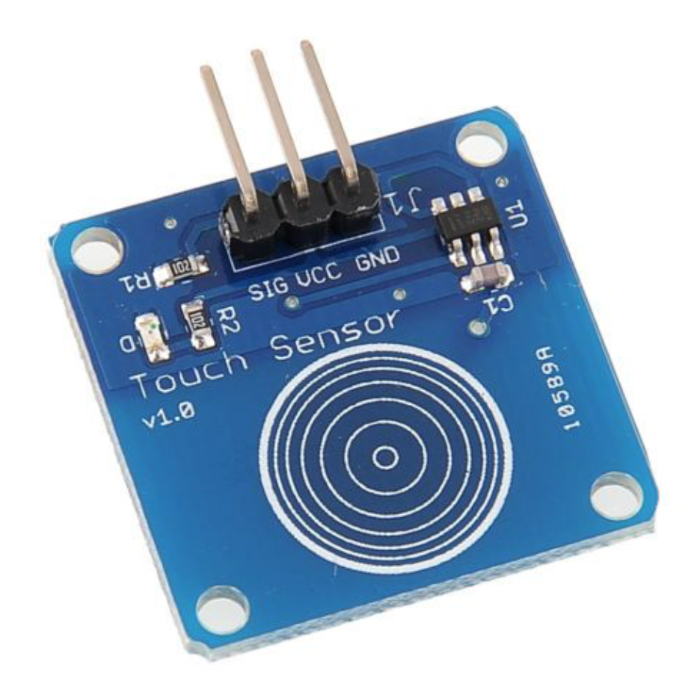

**Figure 1.1: Touch Sensor**

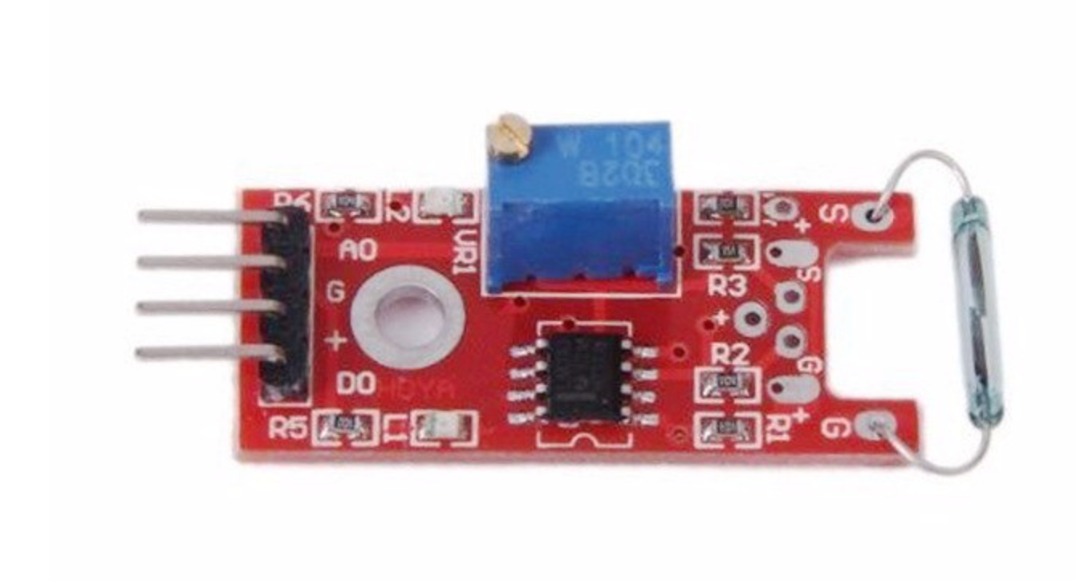

**Figure 1.2: Mini Magnetic Detection Sensor**

Section 6: Programming for interaction

For this project pin A0 and pin 2 were used as inputs and pins 9, 10, and 13 were used as output pins. Pin A0 was used for the input of the mini magnetic detection sensor and pin 2 was used for the input for the touch sensor. Pins 9 and 10 were used as the pins to control the two servos that were used to move the ears. Lastly pin 13 was used for the servo that moved the mouth of the animatronic.

Firstly, two libraries were needed: CapacitiveSensor and Servo. These were downloaded from the Arduino website. Each servo motor was labeled as “left_ear_servo”, “right_ear_servo”, and “myservo”. Four variables were defined for the angles of the motors and each of the sensors.

In the setup, the pins discussed previously are defined. The servos are defined using the library’s “attach” command, and a serial monitor was initiated to decide on proper calibration.

In the loop, a few “if” and “for” statements were used. For the ears and touch sensor, the serial monitor output a signal of anywhere from 200-5000 when touched in different rooms. The initial “if” statement gives a value for the sensor that initiates movement of the two servos. If value is greater than the number, the motors are turned on using digitalwrite(pin#, HIGH). Two for statements with a delay between were implemented to turn the motor back and forth, wiggling the ears by defining angles and rotational speed. An “else” statement begins with making sure the ears stay at their current angle before digitalwrite-ing the servos back to LOW (off), again with a delay to reduce noise. For the mouth, a similar concept was used. If the status of the switch was disconnected, actually defined as LOW, myservo.write was used to put the motor at a certain angle. Two “for” commands were again used to make the mouth move up then down, and an “else” was added to turn the motor back off.

Section 7: Lessons learnt and suggestions

1. What we learned.
   1. Basics of how to code using arduino
   2. The differences between servos, stepper motors, and regular DC motors
2. What went wrong and how it was fixed
   1. We had a lot of things drawing power so sometimes sensors or servos would not work as expected. To fix this we added two battery packs to help supply power.
   2. We were unable to get the audio to sync up with the movement of the mouth. To fix this we just played our audio manually.
   3. At the beginning the touch sensor would work intermittently. To fix this we lowered the sensitivity on the touch sensor.
   4. Initially the group planned to have a sound sensor to trigger the ears to move but not much information on the sound sensor could be found and when information was found neither of the three team members could get it to work. To fix this the sound sensor was replaced with a touch sensor.
3. Things that could be used to improve the experience of this project
   1. The time frame we were given was really short. (It was nice having the milestones due, because it prevented groups from procrastinating too much)
   2. Give more lessons on arduino. There was not much information given on how to code for arduino or what they different types of syntax mean (as mechanical engineers we are not exposed to coding too much)
   3. Either make the project extra credit or give an alternative to the project. Not everyone in the class was motivated or interested in this project
   4. Allow the groups to decide what they want to do as their project. For example in M&I we were able to choose what our project did. The only requirement was that there had to be at least one input and one output. This allows for more creativity and allows each group to have something different.

Section 8: Personnel and bill of materials

**(a) Personnel**

|  |  |  |
| --- | --- | --- |
| **Task** | **Main Personnel** | **Secondary personnel** |
| Structure design | Gerson V. |  |
| Chassis/Model Development | Gerson V. |  |
| Creating Joints & Motor Interface | Gerson V. | Allison Toms |
| Integrating and Interfacing Sensors | Alison Toms | Eduardo Garcia |
| Overall Program & Integration | Alison Toms | Eduardo Garcia |
|  |  |  |

**(b) Bill of materials**

|  |  |  |  |  |  |
| --- | --- | --- | --- | --- | --- |
| **No.** | **Description** | **Website/comment** | **Qty.** | **Unit $** | **Total $** |
| 1 | Arduino MEGA 2560 | Provided | 1 |  |  |
| 2 | L-shaped Steel bar | 6 feet long and 1 inch wide | 1 | 12.74 | 12.74 |
| 3 | Nuts & Bolts | Scrap | 12 ea. |  |  |
| 4 | Aluminium Wire | 50 feet roll | 1 | 3.48 | 3.48 |
| 5 | Mask | Blank white mask for support | 1 | 3.99 | 3.99 |
| 6 | Black Cloth | Scrap | 1 |  |  |
| 7 | Sensor Box |  | 1 | 12.99 | 12.99 |
| 8 | Servo Motors | Pack of 5 | 1 | 11.78 | 11.78 |
| 9 | Battery Pack | Holds 4 AA | 2 | 1.89 | 3.78 |
| 10 | Breadboard/Wires |  | 1 | 11.99 | 11.99 |
| 11 | Elf Ears |  | 1 | 4.49 | 4.49 |
| 12 | Electrical Tape | Not purchased |  |  |  |
|  | **Total** | **(doesn’t include tax)** |  |  | **$65.24** |

The total cost of this project was $65.24 plus taxes.

**References**

# [1] Animatronics Face of UTSA's President, Dr. Ricardo Romo, <https://youtu.be/xkze1_hnam0>

# [2] ROMOBOT - ANIMATRONIC FACE ROBOT

# <https://www.instructables.com/id/RomoBOT-Animatronic-Face-Robot/>

[3] Smith, Jason Poel. “Halloween Props that Turn to Look at You as You Walk By.” *DIY Hacks*

*and How To’s,* Instructables. 2014.

<https://www.instructables.com/id/Halloween-Props-That-Turn-to-Look-at-You-as-you-Wa/>

[4] Medonis, Mark “*Maxwell the Robot - Animatronic Becomes Android*.” [Online]. Available:

<http://www.medonis.com/animatronics.html>

[5] “Building an Animatronic Gorilla Head” [Online]. Available:

<https://www.servocity.com/blog/building-an-animatronic-gorilla-head>

[6] A. Sanjeev, “How to Use a Hall Effect Sensor With Arduino | Arduino,” *Maker Pro*,

04-Dec-2018. [Online]. Available:

https://maker.pro/arduino/tutorial/how-to-use-a-hall-effect-sensor-with-arduino. [Accessed: 04-Dec-2018].

**Appendix A: Code**

**#include <CapacitiveSensor.h>**

**#include <Servo.h>**

**// for ears - touch sensor:**

**CapacitiveSensor cs_4_2 = CapacitiveSensor(4, 2);**

**Servo left_ear_servo;**

**Servo right_ear_servo;**

**int angle = 0;**

**// for mouth - reed switch:**

**int sensor = A0;**

**int rstatus;**

**Servo myservo;**

**int pos = 0;**

**void setup()**

**{**

**// for ears - touch sensor:**

**cs_4_2.set_CS_AutocaL_Millis(0xFFFFFFFF);**

**Serial.begin(9600);**

**pinMode(9, OUTPUT);**

**pinMode(10, OUTPUT);**

**pinMode(2, INPUT);**

**left_ear_servo.attach(9);**

**right_ear_servo.attach(10);**

**// for mouth - reed switch:**

**Serial.begin(9600);**

**pinMode(sensor, INPUT);**

**myservo.attach(13);**

**}**

**void loop() {**

**// for ears - touch sensor:**

**long sensor1 = cs_4_2.capacitiveSensor(900);**

**Serial.println(sensor1);**

**if (sensor1 >= 5000) // ←-**

**{**

**digitalWrite(9, HIGH);**

**digitalWrite(10, HIGH);**

**for (angle = 0; angle < 50; angle +=5)**

**{**

**left_ear_servo.write(angle);**

**right_ear_servo.write(angle);**

**delay(20);**

**}**

**for (angle = 50; angle >=1; angle -=5)**

**{**

**left_ear_servo.write(angle);**

**right_ear_servo.write(angle);**

**delay(20);**

**}**

**}**

**else {**

**left_ear_servo.write(angle);**

**right_ear_servo.write(angle);**

**digitalWrite(9, LOW);**

**digitalWrite(10, LOW);**

**delay(2000);**

**}**

**// for mouth - reed switch:**

**rstatus = digitalRead(sensor);**

**Serial.println(rstatus);**

**if (rstatus == LOW){**

**for (pos = 0; pos <= 180; pos += 5){**

**myservo.write(pos);**

**delay(15);**

**}**

**for (pos = 180; pos >=0; pos -= 5) {**

**myservo.write(pos);**

**// delay(15);**

**}**

**}**

**else{**

**myservo.write(pos);**

**digitalWrite(13, LOW);**

**}**

**// delay(200);**

**}**

**Appendix B: Arduino Wiring**

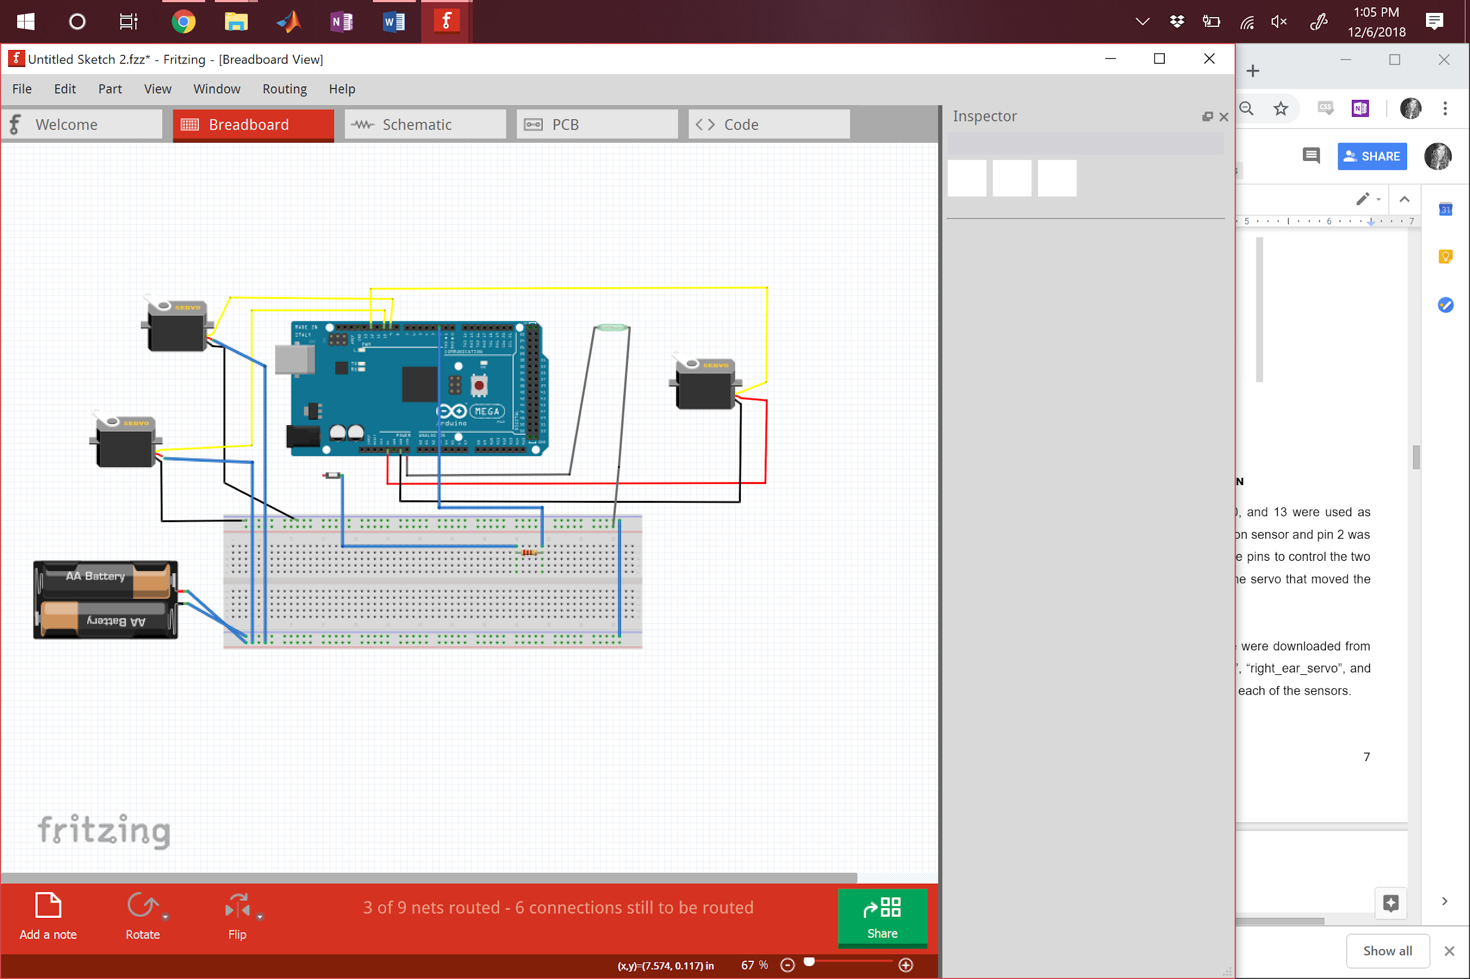

**Appendix C: Figures**

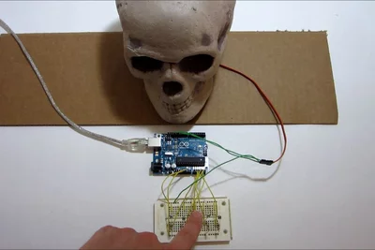

*Figure 1: Motion-detecting skull*

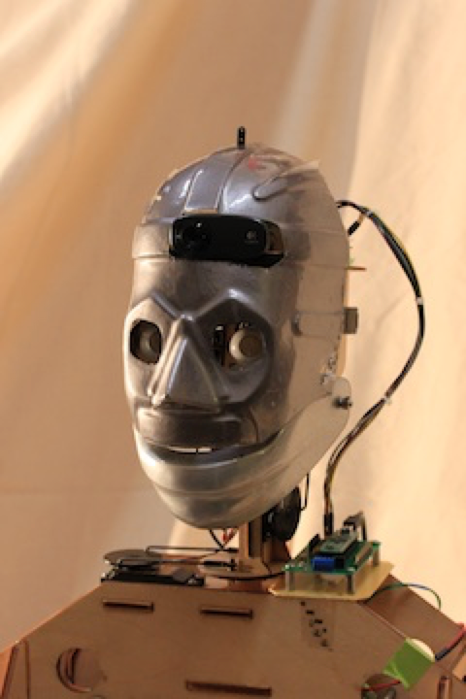

**Figure 2: Maxwell**

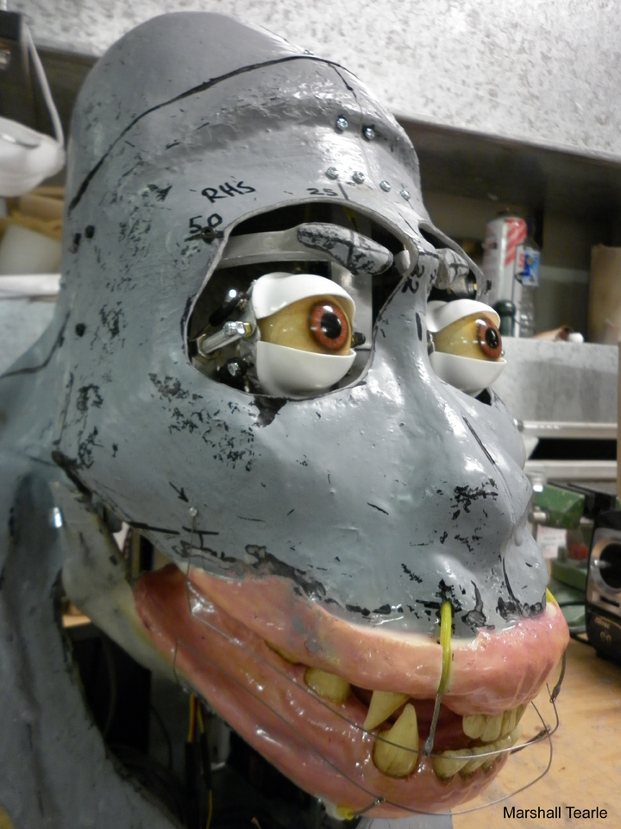

**Figure 3: Gorilla head**

**Appendix C: Photos**

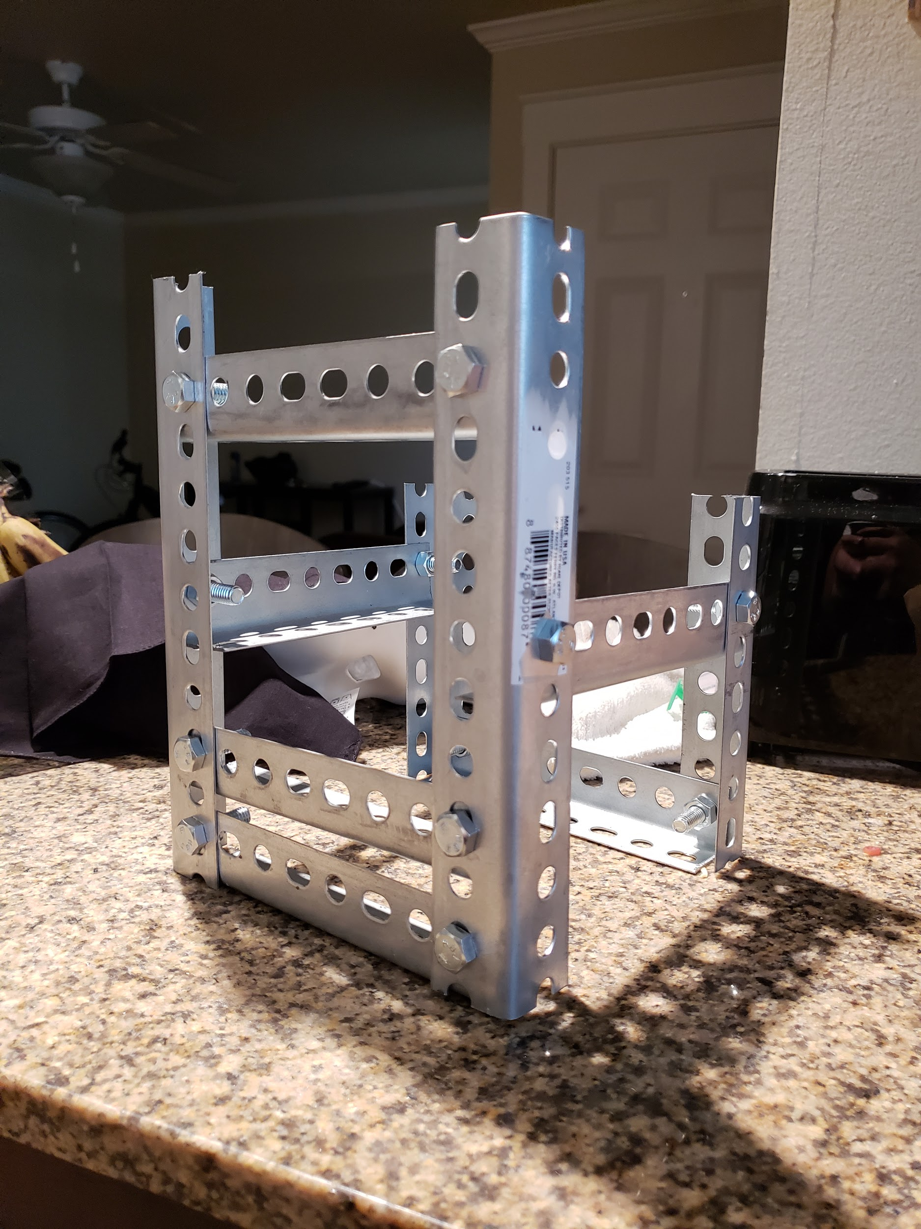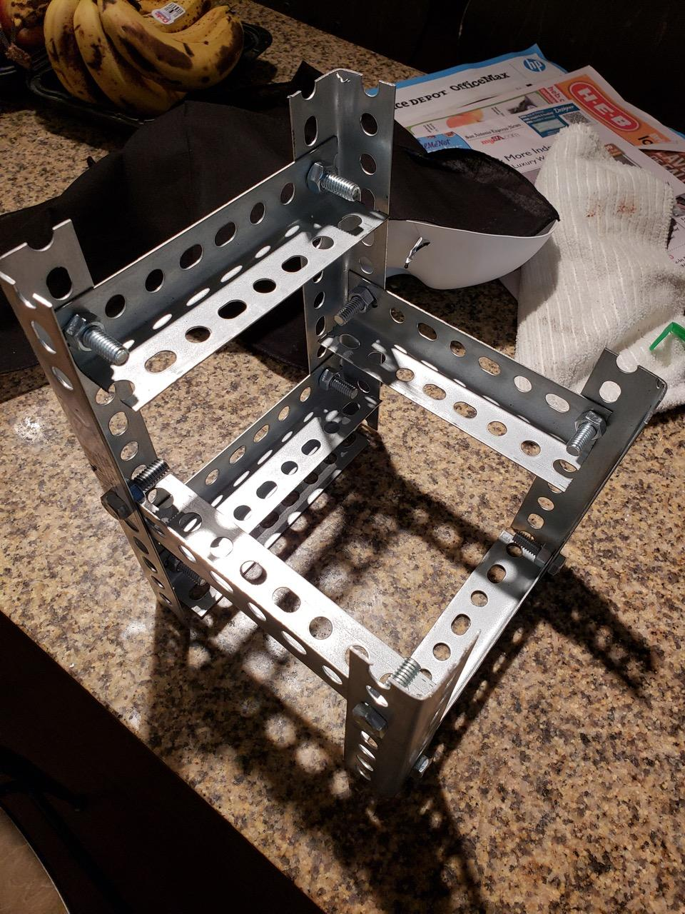

Photo 1:Base Structure

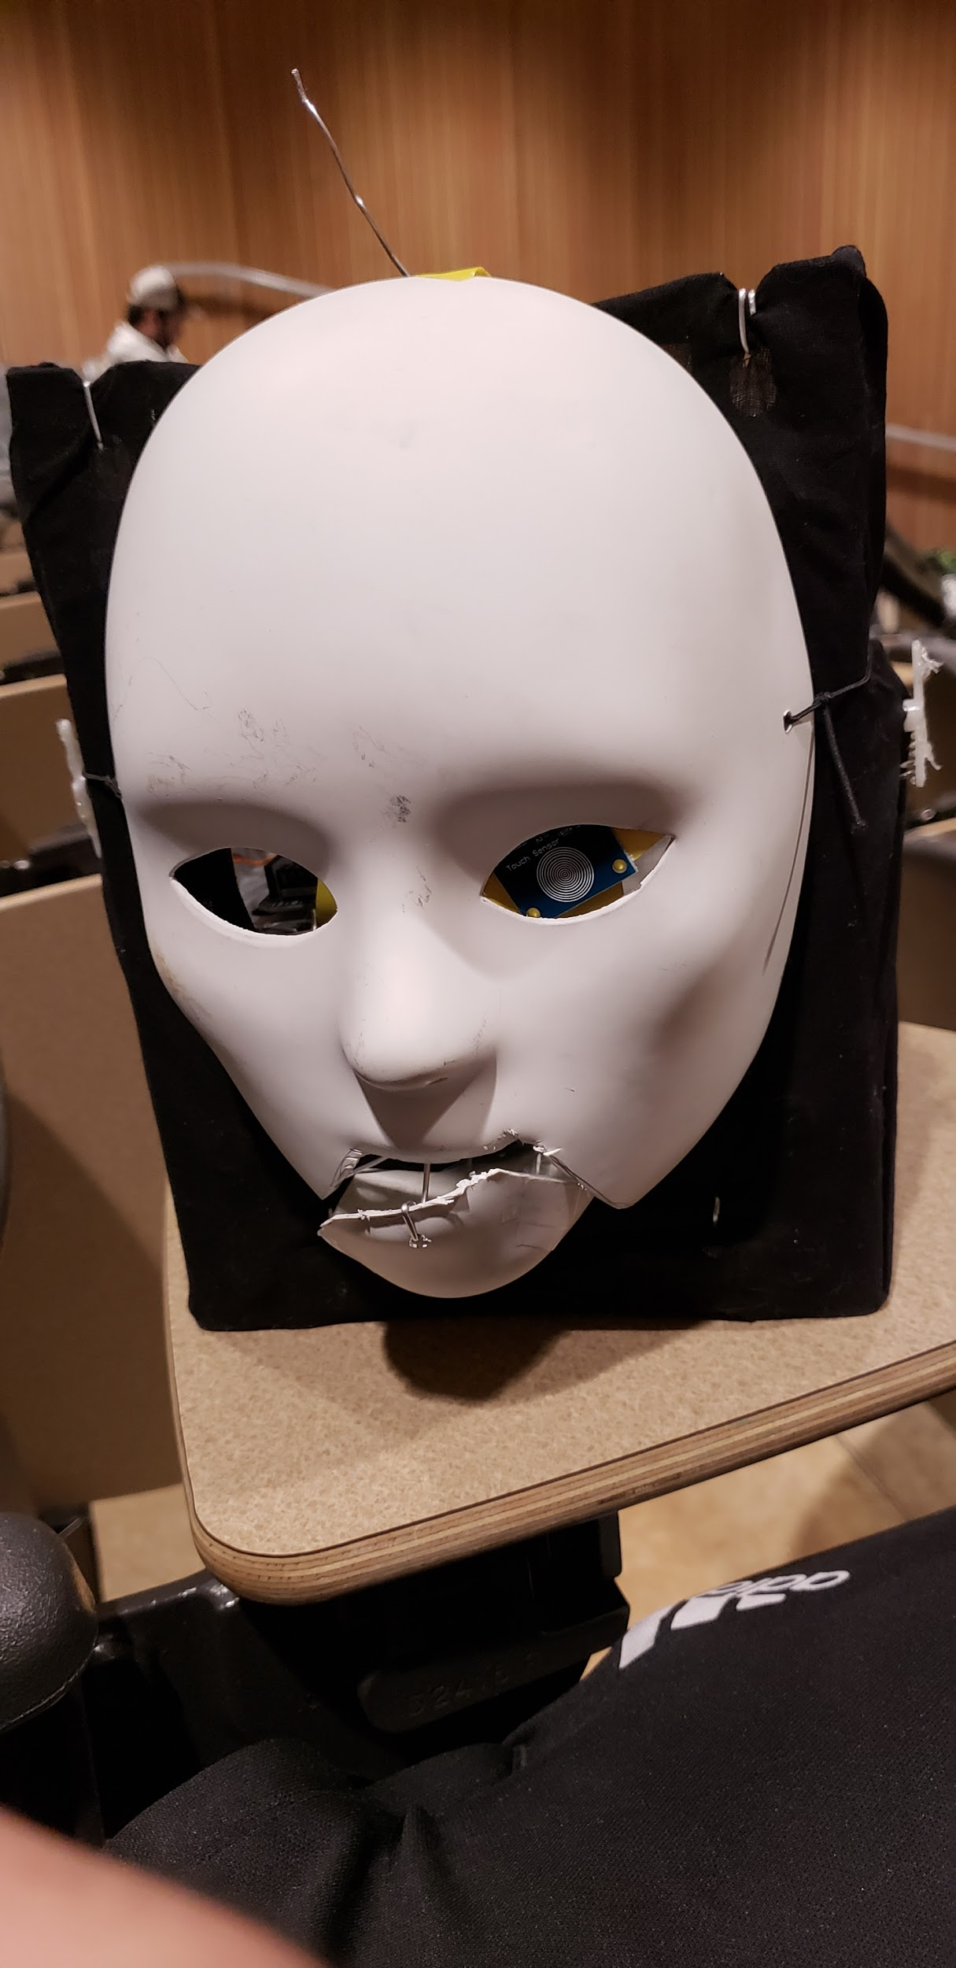

Photo 2: Bare naked mask showing the base of the face

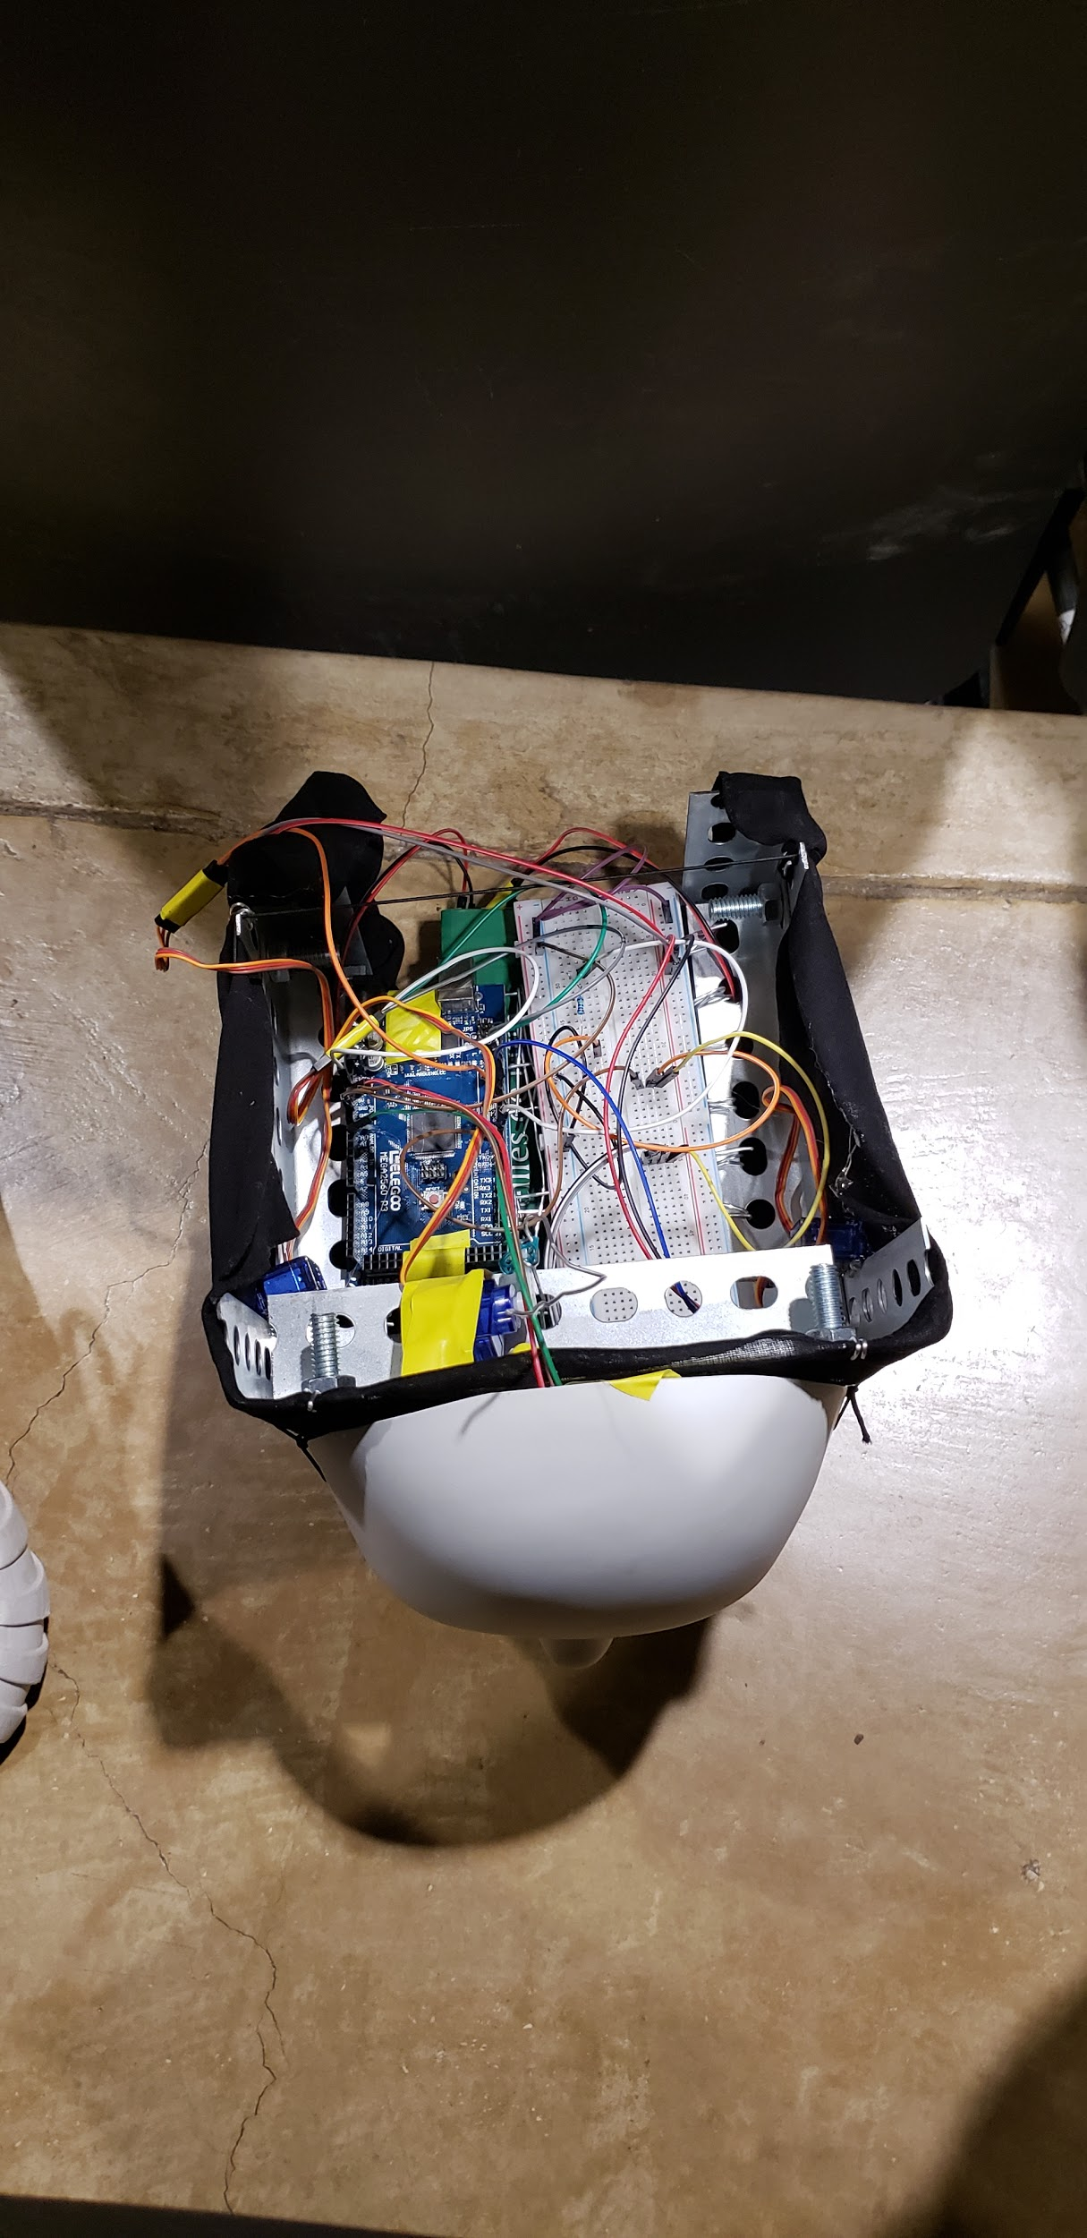

Photo 3: Breadboard, motor, power source and arduino support